Things Every Family Should Know

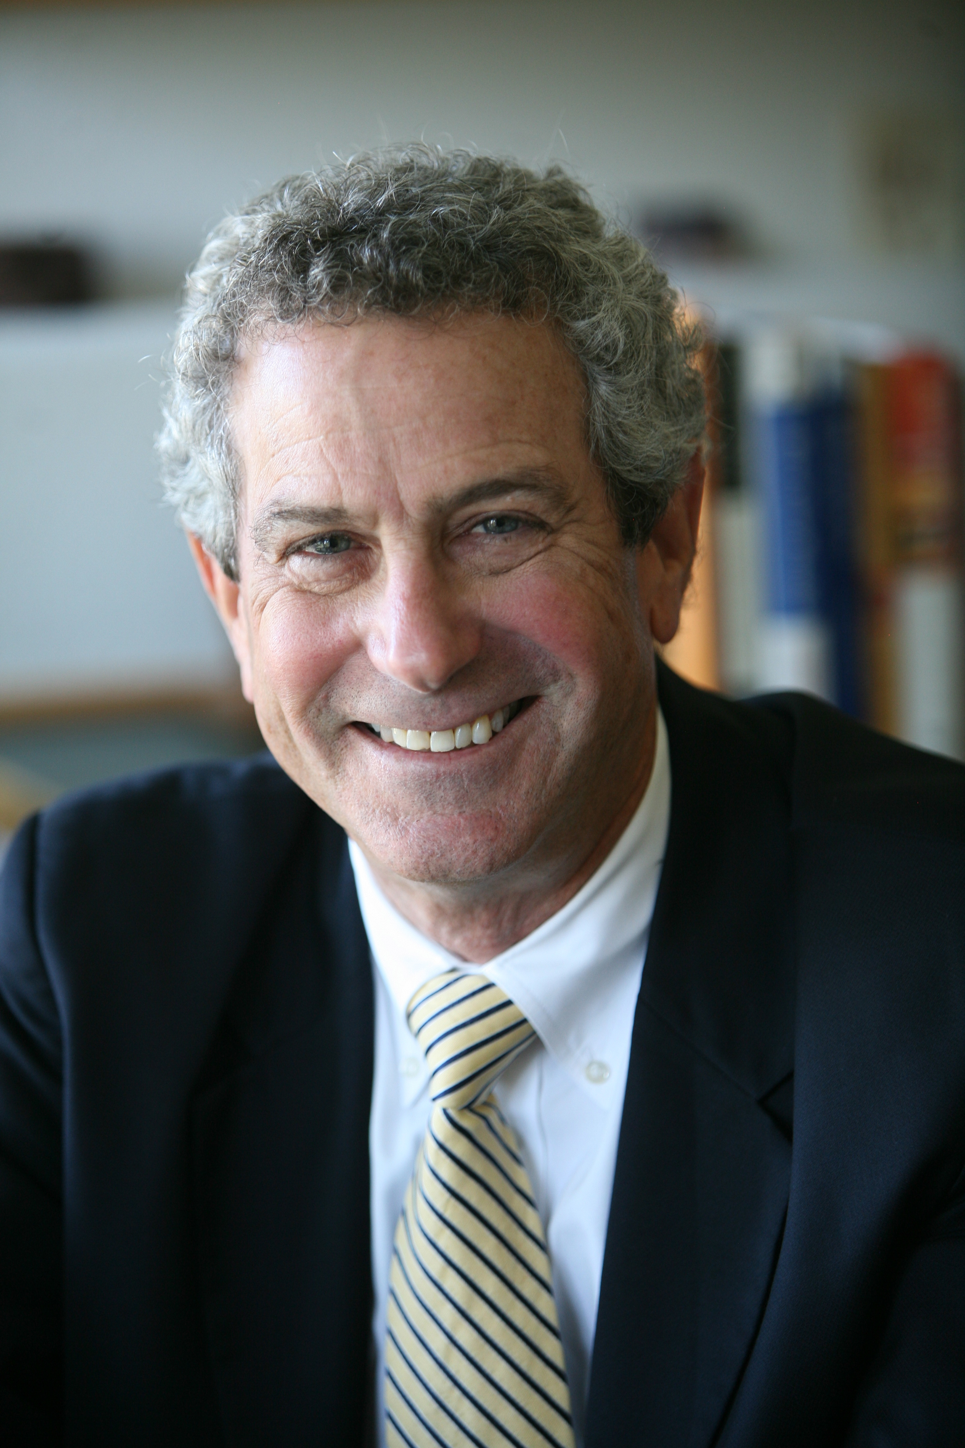
If you or a close friend or relative has recently been diagnosed with cancer, or heart failure or Alzheimer’s disease or a similarly worrisome condition, it’s likely you are feeling a little lost and vulnerable. Suddenly you are on a difficult journey that you didn’t choose to make.

These days, decisions about treatment are often complex. America’s health care system is well-oiled to treat disease but falls down when it comes to communicating, preventing problems, or guiding people through predictably difficult times. It’s no wonder patients and families sometimes feel bewildered, uncertain if they are doing the right things. It’s natural to want to rely on professionals to care for you and your family during this time, but most patients or family caregivers for patients soon learn a sobering fact: you must be prepared to advocate strongly for yourselves.

Here are some things you need to know to avoid problems and pitfalls and to take an informed, proactive approach to getting the best care possible.

I. Take Charge!

The power of modern medicine to treat disease and extend life is awesome. Use it! Know that it’s not necessary to neglect your and your family’s wellbeing while you do.
It’s important to find the very best doctors and health center in your area and to work effectively with your doctor and health care team. Then follow some basic “Take Charge” tips to work effectively with your doctors.

- Write down the questions you have for your doctor
- Bring someone with you to doctor’s visits – a spouse, sibling, or adult child – to support you and lend another pair of ears to the discussion. Consider recording the visit.
- Keep copies of your health record – particularly test and biopsy results, lab reports, physician history and physicals and hospital discharge summaries.
- Keep a daily log of your symptoms and the medications you take

2. Get a Second Opinion – and maybe a third and fourth

In the face of life-threatening illness, second, third and fourth opinions are often entirely appropriate. We are talking about serious illness that threatens to shorten one’s life. Don’t feel awkward at all about gathering several opinions from the best health care centers and teams you can find. Use the internet, local experts and, yes, word of mouth to determine which doctors or centers are best for you.

3. Palliative Care – It’s not just for dying!

I strongly advise that one of the second opinions or consultations you seek is with a palliative care physician or team.

Because palliative care grew out of hospice, many people assume that receiving palliative care means giving up. Not true. These days palliative care is offered together with treatments for cancer, heart, lung, liver, kidney and neurological conditions.

Having a specialized clinical team working to treat pain and other physical discomforts, as well as optimizing a person’s appetite, digestion, (all important) bowels, allows people to sleep better, be more active and at ease. They simply do better both physical and emotionally.

It’s not surprising that people with cancer or other serious conditions who receive palliative care along with disease treatments tend to feel better - and sometimes live longer!

4. Name someone you trust to advocate for you and tell them what you think

The best way I know of to support one another – and protect one’s family from conflict and having to deal with ethics committees or a court – is to make it clear in writing who has authority to speak for you. Make it official. Visit The Conversation Project (http://theconversationproject.org) a national effort to ensure that people’s wishes are expressed, known, and honored. Information and advance directive forms are available at little or no cost from sites such as Everplans (https://www.everplans.com/tools-and-resources/state-by-state-advance-directive-forms)

Give the document to both your doctor and the hospital(s) where you are likely to receive care. Scan a copy of your signed document to share with the person you chose to be your health care agent, as well as other trusted family members and friends. That way your document will always be readily available.

5. Don’t be afraid to change doctors, hospitals or hospice programs

I’ve heard too many people worry that they will hurt their doctor’s feelings if they do or don’t do this or that. As much as I respect my colleagues and am proud to be a physician, doctors exist to serve patients and the public. If you are ill and need care, THIS IS NOT ABOUT DOCTORS, THIS IS ABOUT YOU!

It’s not necessary for every doctor to have a warm and fuzzy personality. But it is essential for you to have confidence in your physician and feel that he or she genuinely cares about your well-being. Feeling comfortable with your doctor is essential to your care.

If you don't like or trust your doctor, it is wise to transfer your care to a doctor whom you can trust.

The same applies to the choice of hospital or medical center you go to. You and your family may have gone to one hospital for years, given birth there, had your gall bladder, appendix and hernia surgery, and recent biopsy or imaging studies there. But if another medical center is offering treatments that may well have value for you, don’t hesitate to find out and get at least some of your care there as well. Don’t feel badly about being disloyal to the hospital you’ve used for years, because, to reiterate, this is appropriately all about you.

As an extension of palliative care into one’s own home, hospice is essential in managing medical matters and supporting families to care well for people through the end of life. Not all hospices are equal. Expect the hospice nurse, social worker and physician to be highly competent, friendly, and both proactive and responsive. If instead – even though they may be warm and caring people – the hospice staff seems uncertain, stretched thin, and slow to respond after hours, ask around, or talk with another hospice program to see if their services are better.

Remember, at the end of the day, what matters most is getting the best care possible for you and the people you love. This is no time to settle for less.

Ira Byock, MD is Founder & Chief Medical Officer, Institute for Human Caring of Providence Health and Services. He is an active emeritus professor at Dartmouth’s Geisel School of Medicine and author of Dying Well (1997), The Four Things That Matter Most (2003), and The Best Care Possible (2012).

